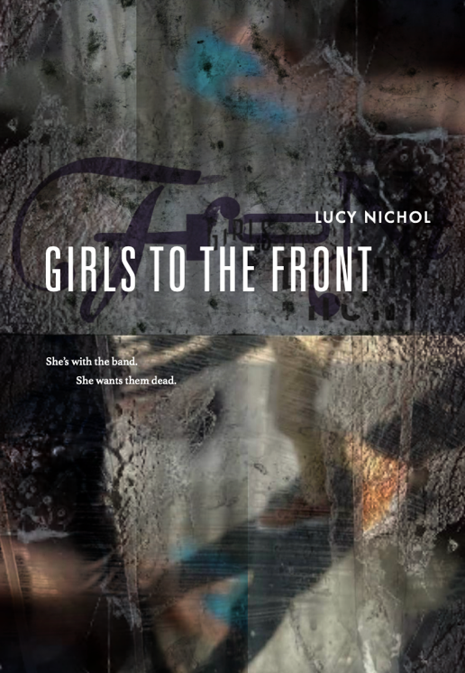

PRESS RELEASE

Revenge thriller takes inspiration from 90s ‘Riot Grrrl’ movement

‘Girls to the Front’

by Lucy Nichol

eBook / Paperback – 16 October 2025

She’s with the band. She wants them dead.

When Roma finds an old VHS tape in a house clearance box, she’s drawn into a dark crime that took place over 30 years ago.

Roma’s discoveries lead her towards a rock band with a bad reputation - and a meeting with a mysterious woman named Kat. But are the crimes on the tape really confined to the past?

A found-footage revenge thriller teeming with feminist fury and 90s nostalgia.

A new thriller from author Lucy Nichol explores women’s safety and the power dynamics of the music industry, looking back to the mid 1990s and the ‘Riot Grrrl’ feminist punk movement for inspiration.

Girls to the Front is a dual timeline thriller that follows student journalist Kat in 1995 as she campaigns for women’s safety after her friend is assaulted during a stage dive at a gig.

Lucy said: “Girls to the Front is my second published thriller – although it’s the first I actually wrote. I always knew I wanted to write a thriller and setting it against the backdrop of the 90s music scene was the perfect way for me to indulge my music fandom too.

“Having read about Bikini Kill’s ‘girls to the front’ policy at gigs in the 90s, and Courtney Love being assaulted during a stage dive, I took that as the starting point, and built a narrative around women’s safety, power imbalances and misogyny. However, while this explores some serious issues, it is, of course, fiction, so I’ve played with murder, mayhem and a little bit of dark magic too - because dreaming up revenge is hugely cathartic and a lot of fun.”
Lucy Nichol, who also writes as Lucy Roth, is the author of When Sally Killed Harry (Avon), No Worries if Not! (HarperNorth), The Twenty Seven Club and Parklife (released via her own imprint Lark), both of which celebrate the 90s music scene. She has also published two non-fiction works exploring mental health stigma with Hachette and Trigger.

To conjure the vibes of the 90s music scene, Lucy commissioned renowned 4AD record label designer, Chris Bigg, to create a cover that speaks directly to music fans.

On commissioning designer Chris Bigg Lucy added: “I grew up poring over 4AD record sleeves as the designs were so unique and so distinctly 4AD. I bought albums by The Breeders, Pixies, Belly and Kristin Hersh, and was so taken that a few terribly naïve sketches of them made their way into my GCSE work! So being able to work with Chris on the cover design for my book is a bit of a dream come true!”

Girls to the Front, which is being released under Lucy’s own ‘Lark’ imprint, will be published in paperback and e-book on 16 October 2025.

ENDS

For further information contact Lucy directly at hello@lucynichol.com.

A full press pack can be found at www.lucynichol.com/press-pack/

Early praise for Girls to the Front:

"Propulsive, fierce and hugely satisfying, Girls to the Front is a feminist tour de force!" Lisa Timoney, author of ‘The Daughter She Gave Away’
“A dark, feminist thriller with a punk protagonist exacting her revenge like a real-life Martha Splatterhead.” Adem Tepedelen, Co-author of ‘Mud Ride: A Messy Trip Through the Grunge Explosion’
"Girls to the Front shines a powerful light on neglected aspects of an era so formative for those in my generation. It is Lucy Nichol's most powerful work so far." Guy Mankowski, author of bestselling Substack biography 'I Know How to Live: The Life of Kristen Pfaff'

